Phishing URL Detector
Objective
The objective of this project is to develop a simple web-based application that helps users identify potentially suspicious or phishing URLs. The project aims to spread awareness about phishing attacks and demonstrate how basic URL analysis can help users recognize unsafe websites.
Problem Statement
Phishing attacks are one of the most common cyber threats, where attackers create fake websites to steal sensitive information such as usernames, passwords, and banking details. Many users are unable to identify these malicious websites. This project provides a basic solution by analyzing URLs using predefined security checks and informing users whether a URL appears safe or suspicious.
Research Findings
During the research, it was found that phishing websites often use unusual URL patterns such as IP addresses instead of domain names, very long URLs, multiple hyphens, or special characters like ‘@’. These characteristics are commonly used to deceive users into believing that a fake website is legitimate. By checking these indicators, users can reduce the risk of falling victim to phishing attacks.
Methodology
The project was developed using HTML, CSS, and JavaScript. First, a user interface was designed where users can enter a website URL. After clicking the Analyze URL button, JavaScript performs several security checks on the entered URL. The program checks whether the URL contains an IP address, the ‘@’ symbol, excessive length, or multiple hyphens. Based on these checks, the application displays whether the URL appears safe or suspicious along with the reason.
Tools Used
HTML
CSS
JavaScript
GitHub
Microsoft Word
Web Browser (Google Chrome)
Implementation
The application consists of three main files:
Index.html creates the webpage structure.
Style.css provides the design and user interface.
Script.js performs the phishing detection logic.
The application follows a rule-based approach to identify suspicious URLs. After analyzing the URL, the result is displayed on the screen with an appropriate message. If suspicious characteristics are detected, the application warns the user. Otherwise, it indicates that the URL appears safe.
Screenshots
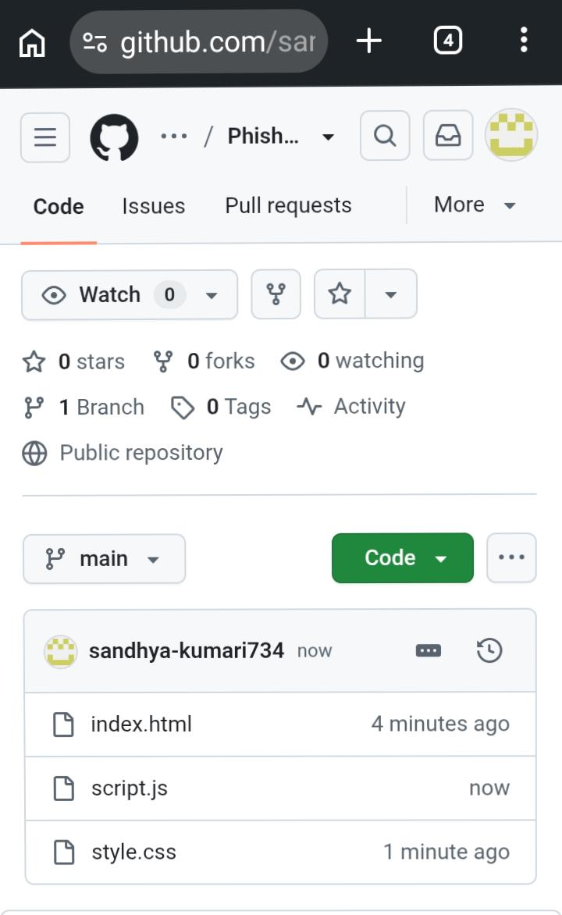
Figure 1: Home page of the Phishing URL Detector.

Figure 2:- index.html source code

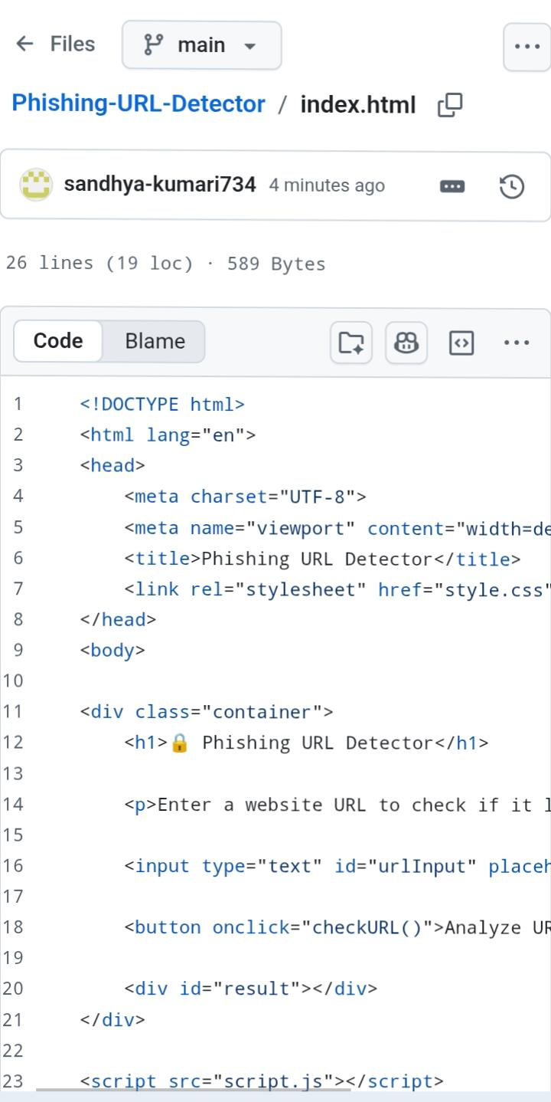

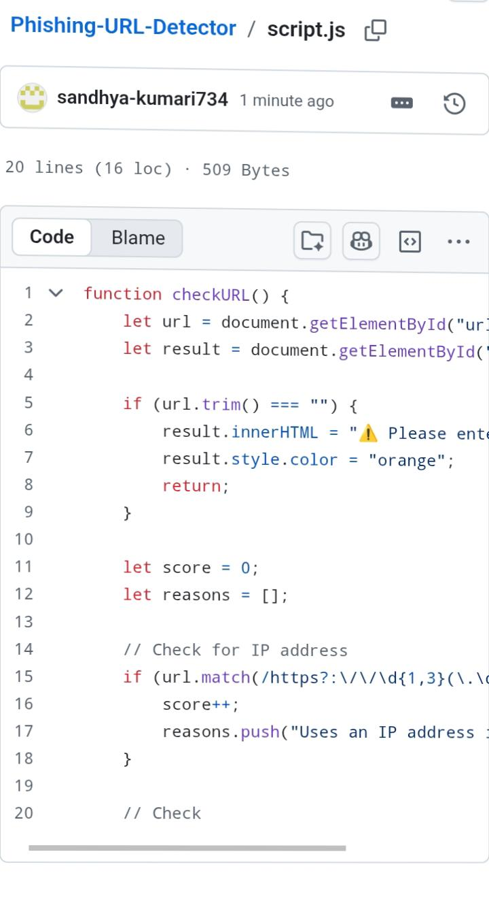
Figure 3:- style.css source co

Figure 4:- script.js source

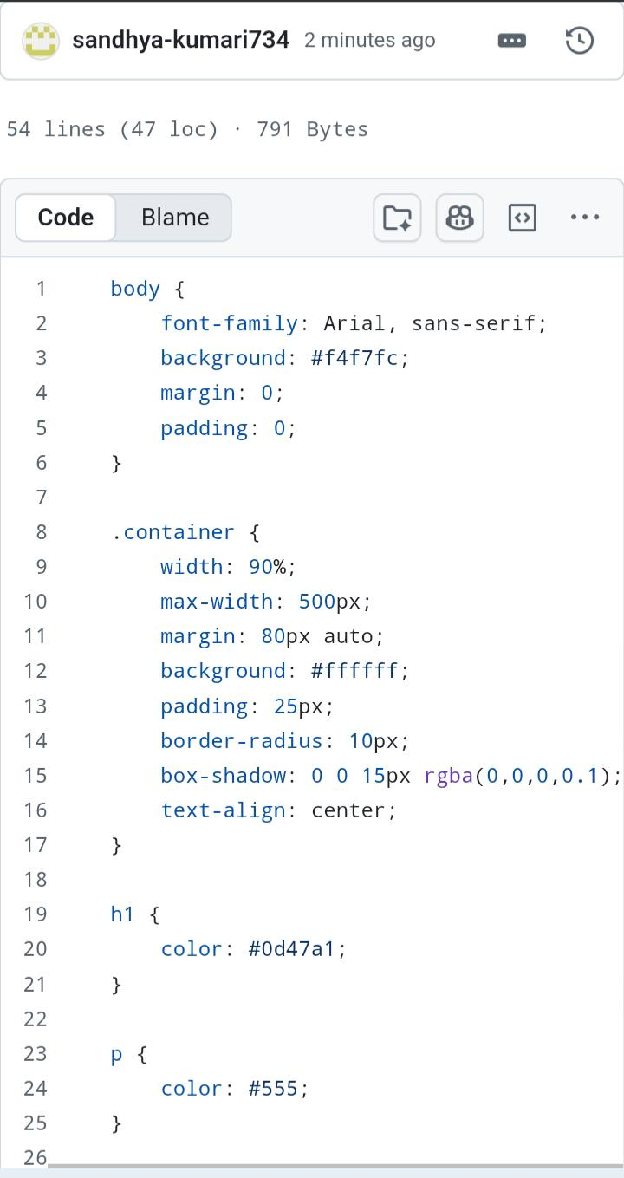

Results
The project successfully performs basic phishing URL detection using predefined security rules. It correctly identifies common suspicious URL characteristics and provides an easy-to-understand result for the user. The application demonstrates how simple cybersecurity techniques can help users recognize potentially dangerous websites.
Challenges
Understanding phishing URL characteristics.
Implementing detection logic using JavaScript.
Designing a simple and user-friendly interface.
Testing different types of URLs for accurate results.
Future Scope
The project can be improved by integrating machine learning techniques for better phishing detection. Future versions may include real-time URL verification using online threat intelligence databases, browser extension support, and advanced security analysis for higher detection accuracy.
Conclusion
The Phishing URL Detector is a simple cybersecurity project that demonstrates basic phishing detection techniques using HTML, CSS, and JavaScript. The project helps users understand common phishing indicators and encourages safe browsing practices. It also provides practical experience in web development and basic cybersecurity concepts.

